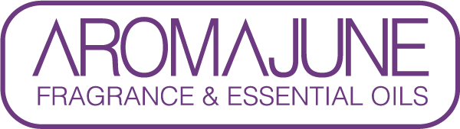

DATE : {{DATE}}
TO : {{CUSTOMER}}
SUBJCET : BSE/TSE FREE CERTIFICATE
PRODUCT NAME : {{PRODUCT}}

This product is manufactured using non-animal raw materials.

Legislation concerning BSE/TSE status applies only to material of animal origin. As the
requested product is not based on animal raw materials further certification on our behalf is therefore not mandatory.



